Jordan Carney | Caleb Gomer | Jason C. Tierney | Nick Workman

Apple ink | Version: October 28, 2012



A replacement for the GVSU myBanner system.

**Design Plan**

Contents

Contextual Inquiry 7

Process 7

What did we ask? 7

What additional source of information did you review? 7

Work Activity Notes 8

Work Roles 8

User Classes 9

Average Student 9

Power User Student 9

Confused Student 9

Personas 10

Linus Torvalds - Confused Student 10

Bill Gates - Average Student 10

Steve Jobs - Power User 10

Scenarios 11

Linus Torvalds 11

Bill Gates 11

Steve Jobs 13

UC-01 - User checks grades for specified term 13

UC-02 - User searches for class 14

UC-03 - User checks class schedule 14

UC-04 - User views bill 15

UC-05 - User pays bill using credit card 16

UC-06 – User registers for parking permit 17

UC-07 – User declares major(s) 17

UC-08 – User declares minor 17

UC-09 – User Quick Registers for classes 19

UC-10 – User checks financial aid 19

Work Environment 20

Ideation 20

Icons 22

Logos 23

Conceptual Design 24

Low Fidelity Prototypes 24

Design Guidelines 28

Feedback 28

Navigation 29

Minimizing Error Handling 29

Simplicity 29

Consistent Design 29

Color 29

Alignment 30

Conciseness 31

Graphics / Icons 31

Formative Evaluation 31

Early Design Changes 32

Project Team Work Roles 35

Jordan Carney 35

Caleb Gomer 35

Jason Tierney 36

Nick Workman 36

Product Description 37

UX Target Table 37

UX Target Table 38

High Fidelity Prototype Task List 39

Benchmark Tasks 39

T1: Log in to Better Banner 39

T2: Change Better Banner Password 39

T3: Change GVSU Network Password 39

T4: View Weekly Schedule for Current Semester 39

T5: Register for BIO 230, Section 01 40

T6: Check Midterm Grades for Current Semester 40

T7: Check for Holds on Account 40

T8: Log out of Better Banner 40

Implemented Tasks from Contextual Analysis 41

User logs in 41

User signs out 41

User checks grades 41

User searches for classes 41

User registers for class 41

User checks class schedule 41

User removes class 41

User checks registration status 41

User checks registration history 41

User views major information 41

User views advisor information 41

User views transcript 41

User views holds 42

User changes Better Banner password 42

User changes network password 42

User updates Address 42

Unimplemented Tasks from Contextual Analysis 42

User views bill 42

User pays bill 42

User registers for parking 42

User checks financial aid 42

User applies for financial aid 42

User declares major(s) 42

User declares minor(s) 42

User changes major 43

User checks schedule for month 43

User exports schedule to iCalendar / Outlook 43

User requests formal/printed transcript 43

User sets up meeting with counselor 43

User updates phone 43

User updates e-mail 43

User views ethnicity / race 43

User updates security question 43

Screen Shots 43

Screenshot Analysis 44

Video Demo 47

Design Highlights 48

Evaluation Plan 48

Goal and Purpose 48

Team Roles 50

Participants 50

Environment 51

Procedures 51

Welcome Dialog 51

Informed Consent Form 51

Test Steps 52

End of Participant Study Results 52

Data Gathering 52

Collecting the Data 52

Summarizing and Analyzing the Data 53

Evaluation Results 56

Rough Data 56

Brief Summary and Analysis of Data 61

Design Changes - Part 2 61

Conclusion 61

Previous Team Roles 63

Jordan Carney 63

Caleb Gomer 63

Jason Tierney 63

Nick Workman 63

Team Rules 63

Informed Consent Form 64

Standard Welcome Dialog 65

Example Data Collection Table 66

End of Participant Study Survey 67

myBanner Expert Analysis Questionnaire 68

# Contextual Inquiry

We decided to collect data from current GVSU students during their lunch break in Fuel. We chose Fuel as a viable location because it is a common area where students meet for lunch. This provided us with a diverse set of students differing in field of study and tech savviness.

## Process

We set up a mini competition for students as a fun alternative to the average survey. In pairs the students were both asked to complete simple everyday tasks inside of myBanner. We gauged the results of the contest by the number of total clicks to perform the given task. The two computers used were both already logged into myBanner to provide a stress free setting for students who might have been concerned about security. Overall, we conducted these surveys with twelve participants.

### What did we ask?

We selected questions off of a list of common and not so common tasks that can be performed on mybanner. Each was a task that should be performed multiple times throughout an average student’s career. These were tasks such as changing your password, viewing your week at a glance, and accessing the myPath student advising software.

### What additional source of information did you review?

Each student was asked their age, major, and their tech savviness rating (1 - 10) before the test began. After the test we also asked them if they had any additional thoughts on myBanner as a whole and if they had any suggestions for future improvements.

# Work Activity Notes

After analyzing each of the users, we created the following work activity notes that fairly represent the users we tested.

1. The average number of clicks for purchasing parking permit and returning to myBanner was nearly double that of other tasks.
2. There is no way to return to the main myBanner menu from most locations in the system.
3. Users desire home button.
4. The flow of control in myBanner confused many students.
5. Users cannot decided which subsection to search for simple myBanner tasks.
6. Most users do not have a mental map of more than a few tasks on myBanner.
7. On average, users felt their tech savviness was about 6 out of 10.
8. Users feel the clicks they undergo are terribly inefficient.
9. User feels registering for classes is an annoyance.
10. Users felt like a failure after attempting simple tasks complicated by myBanner.
11. If user leaves myBanner page for anything, they must log back in.
12. The average clicks per task was 7.
13. User feels myPath is too deep in clicks and should be more easily accessible.
14. User feels navigation should be more descriptive than the links currently provided.
15. The tasks resulting in the least number of clicks on average was viewing schedule.
16. Users feel indifferent about the user experience; nothing positive to say.
17. Users avoid myBanner whenever they do not absolutely need to use it.
18. Users felt myBanner had many useless features that cluttered the overall appearance.
19. Users experienced aggravating, non-functional buttons.
20. Users felt the words pin and password were used incoherently.

# Work Roles

We decided to use the following Work Roles for the updated BetterBanner system.

* **Schedule Advisers** - Helping students figure out which classes to take / paths for graduation, using myPath. (not covered in the scope of this project)
* **Secretaries** - Overrides for student schedules (not covered in the scope of this project)
* **Parents** - Access to payment options for students. (not covered in the scope of this project)
* **Students** - View grades, pay for parking permits, pay tuition, sign up for classes, etc.
* **Admins** (not covered in the scope of this project)
* **Faculty/Staff** (not covered in the scope of this project)

# User Classes

We came up with three different user classes to define the most general set of users who may use myBanner (student section) on a regular basis. These user classes are average, power user, and confused (beginner). Each of these user classes is further defined below.

### Average Student

* Gender - Female
* Ethnicity - White
* Age - 20
* Expertise with myBanner - Has used myBanner and has learned where some things are. Particularly good at signing up for classes and checking schedule.
* Experience with technology - Good with E-mail, Facebook, Google, and generally understands how websites work.

## Power User Student

* Gender - Male
* Ethnicity - White
* Age - 20
* Expertise with myBanner - Has used myBanner frequently and understands what most of it does
* Experience with technology  - Advanced skills navigating websites, primarily myBanner/Blackboard/Cramster and has a good understanding how they work.

### Confused Student

* Gender - N/A
* Ethnicity - Varies
* Age - 18
* Expertise with myBanner - Just started using myBanner and cannot find anything. Very frustrated with the system.
* Experience with technology - Very little experience on the web besides Facebook/Twitter and gets very confused when navigating new websites.

# Personas

The following personas illustrate a key person that fits one of the user classes we defined in the previous section. Linus Torvalds is our confused student, Bill Gates is our average student, and Steve Jobs is our power user student.

## Linus Torvalds - Confused Student

Linus is a little confused. At 18, he just started school at GVSU and spends most of his time getting completely wasted in his dorm with friends. He doesn’t have a job or even dream of it at this point. Right now he’s at college to waste his parents’ money and have a good time. His hobbies are mindlessly searching for diamonds Minecraft, and surfing Facebook during class. He’s always dreamed of screwing around with computers but just can’t seem to find the time.

## Bill Gates - Average Student

Bill is an aspiring Economics major. He has been going to GVSU now for the past two years. Although he should be entering his junior year, he actually only has one year left because of all the AP credits he transferred in. Bill currently works at the Connection and manages his employment information on myBanner.  
  
Although Bill is an excellent student when it comes to his classes and employment, he finds myBanner to be simply a tool in which he can keep tabs on his school life. He primarily uses myBanner to register for classes, check his final grades, to see his weekly class schedule, and to check to see if he was paid on Tuesday.  
  
Bill would like to see some improvements, specifically with navigating the myBanner system. He often finds it difficult to perform simple tasks such as registering for a parking permit. This task took him nearly 25 minutes.

## Steve Jobs - Power User

Steve is a late bloomer, hitting puberty at the age of 19. Let’s just say high school was a rough time for Steve. Never having the confidence to “get with the ladies” and not being fit enough to play sports, Steve spent most of his time in the computer lab playing games and researching new ideas. A computer science professor feels bad for Steve, so together they take on side projects like learning how to program. Steve’s passion for technology has been growing into his college career, driving him for a master’s degree in computer science as well as EE.   
  
Steve utilizes the Linux terminal for his everyday life but for class information is forced to use myBanner and Blackboard. Using Linux has trained Steve to memorize hundreds of commands, so learning the small maze of links on myBanner was a simple task. Because myBanner has not changed its interface in years, Steve sees it as simple tool to use but rarely sees the need to.

# Scenarios

The following scenarios try to explain the general audience’s use of the myBanner system. These scenarios are further expand upon the personas constructed earlier.

## Linus Torvalds

It’s 7am on Linus’ registration date. He stayed up the entire night making Jäger bombs, and needs to register for one of the last open spots of Chemistry next year. He has a lot of trouble reading the small text on the website, and the plain white background is so bright that he can’t concentrate. He accidentally double clicks the Financial Aid link which takes him to an Eligibility Screen. He’s not sure if he clicked the right link, so he presses the “Menu” button at the top of the screen. He’s expecting to see the menu where he can select “Student”, but he’s still in the financial aid section and is very confused.  
  
After pressing the “Menu” button for a second time, he’s pretty sure he’s back to the main screen. Linus carefully selects “Student” this time and then “Registration. He thinks he should select the current term, so he presses “Select Term”. The default selection is not next semester, though, but the following one. He stumbles through the popup menu to find the correct Fall semester, and presses “Submit”. Now he’s back at the Registration screen, and sees the “Search for Classes” link. After pressing it, he is asked which term to select. Now Linus is sufficiently irritated that he quickly makes another Jäger Bomb to help him get over it.  
  
Linus finally gets to the “Look Up Classes” screen, and selects Chemistry as the subject. He doesn’t remember the course number, so he doesn’t use the advanced search. He’s presented with a list and remembers he needs “Principles of Chemistry 1”. He views the sections, but can’t make out the difference between the small letters that designate a class for Monday, or Tuesday, etc. Fed up with this problem, he selects the first one he sees, and presses “Register”. He is then taken to a completely new screen and presented an error message that he doesn’t understand. Linus outsmarts the system by using the “back” button, and chooses another section. This time when he presses “Register”, a popup window appears and tells him that his changes have already been submitted. He has no clue what this popup is talking about, and he’s so angry he punches the screen of his laptop clean through.  
Linus soon realizes he now has to leave his dorm and find a computer lab to complete registration, but elects to pass out on the floor instead.

## Bill Gates

Bill would like to finally park on campus. He is getting sick and tired of always taking the bus from the Meijer park and ride at 7 in the morning and having to wait for the bus after work at midnight. With a parking pass, Bill can easily decide when he leaves and gets to school. Bill decides the easiest way to register for a parking pass is via myBanner, after all, this is what the GVSU flyer told him to do. Bill would soon realize this was a drastic mistake.  
  
Upon reaching the myBanner system, Bill noticed a sign: “myBanner may be experience outage issues for the next two hours.”  
  
‘Okay,’ Bill thought to himself. ‘I can manage this.’ Bill hopes he can get a successful logon attempt and proceeds to enter in his credentials. Bill successfully logs into myBanner.  
  
“Whew!” Bill exclaims. “That was lucky for me.”  
  
Bill begins to look at the navigation pane he is presented with. He immediately thinks, ‘This navigation pane is a PAIN!’.  
  
Bill clicks the Student link at the top of the page (clearly missing the Parking/Permits hyperlink in the middle of the page). Bill assumed this was the best place to start as it pertained to students. To no avail, Bill hunted and pecked through the Student section and could not find any information for parking / permits.  
  
Bill decided he needed to go back to the main menu. Maybe there was another section there he had missed. But wait, “Where’s the home button?!” Bill exclaimed, very annoyed.  
  
To Bill’s surprise, clicking both the GVSU or the myBanner images did not bring him to the home page as nearly every other website does. He spent nearly 10 minutes looking around and finally came across an interesting link titled RETURN TO MENU.  
  
Upon clicking this, Bill sees the Parking/Permits link. ‘Why don’t they have that on the top navigation bar as they do every other link on this page,’ Bill thought. ‘That violates so many design principles.’  
  
Bill proceeds to click the Parking/Permits link which redirects him away from myBanner and to a normal GVSU web page. “WHAT?!” Bill exclaimed. “I’m no longer in Banner? This is lame.”  
  
Bill shrugs off his redirect and instead click on the link to purchase a Parking Permit. After his purchase, Bill wanted to make sure he was signed out of myBanner. However, Bill can no longer get back to myBanner because it redirected him away from the site. “This is stupid,” Bill said aloud. “How am I supposed to get back to myBanner and logout. They should have opened a new tab/window instead of redirecting me to this page in the same window!”  
  
Bill ended up navigating to mybanner.gvsu.edu instead and logging off that way. Done for the night, Bill decided the next day he would talk to one of his Computer Science buddies who was currently taking an awesome UX design class with Scott Grissom and see if he could redesign myBanner.  
  
“I think,” Bill said, “it shall be called BetterBanner.”

## Steve Jobs

It is 12:00 noon on the first day of class registration for the next school year. Steve’s roommate just frantically woke him up:

“Steve... Steve, you gotta help me out! I forgot to wake up at 7:00 to sign up for classes and if i don't do it soon all there won’t be room left.”  
  
Steve sat up scratched his head, and muttered:

“You still have a list of the CRN numbers I told you to right down right? Give me your computer”  
Still sitting in bed Steve grabbed the laptop and the scribbled class codes:

“At least you were smart enough to log into myBanner for me, this will only take a sec.”  
  
With his knowledge of myBanner Steve navigated to the “Add / Drop classes” screen for the upcoming semester using only four clicks. With a few quick strokes of the keyboard all Steve’s roommate's class CRNS were entered in the boxes and submit was clicked. Steve was a hero! Saving his roommate the misery of not getting into the classes that ratemyprofessor.com told him to take.  
  
**Task Analysis**  
We decided upon the following users tasks in which an average student would use the myBanner system.

## UC-01 - User checks grades for specified term

**Description:** This use case describes the steps required for a user to check his grades for a specific term on BetterBanner.

**Prerequisites/Assumptions:** User has already logged onto BetterBanner.

|  |
| --- |
| Action |
| User selects option for Studentoptions |
| User selects option to view grades |
| User selects option to view their selected Term |
| *Grades for the selected term are shown to the user. If there are no grades for that term, user is notified.* |
| User logs out. |

## UC-02 - User searches for class

**Description:** This use case defines the steps for a user searching for a class in BetterBanner.

**Prerequisites/Assumptions:** User is logged into BetterBanner.

|  |
| --- |
| Action |
| User selects option for Student options |
| User selects the option to Search for Classes |
| User selects appropriate term from list |
| User selects appropriate department code (ACC – Accounting / CIS – Computing Information Systems) |
| User selects *class* |
| User selects appropriate *time slot* for class. |
|  |

## UC-03 - User checks class schedule

**Description:** User checks his class schedule on BetterBanner.

**Prerequisites/Assumptions:** User has already logged onto the system and has already selected courses.

|  |
| --- |
| Action |
| User selects option to view student information |
| User selects class schedule |
| User selects term |
| *Class schedule is displayed for the user’s selected term.* |

## UC-04 - User views bill

**Description:** User views bill for the current term. The bill gives the total amount due for the user as well as ability to pay the bill.

**Prerequisites/Assumptions:** User has already successfully logged onto the system.

|  |
| --- |
| Action |
| User selects option to view billing information. |
| User selects option to view the current bill. |
| *Current tuition bill is displayed to the user.* |

## UC-05 - User pays bill using credit card

**Description:** User pays his current bill on the BetterBanner system.

**Prerequisites/Assumptions:** User has already logged onto BetterBanner.

|  |
| --- |
| Action |
| User selects option to view billing information. |
| User selects option to pay the bill. |
| *Bill is displayed to user with current amount due and total amount.* |
| User selects option to pay the full balance of the bill. |
| *Screen appears with current balance entered into text box for amount to pay.* |
| User either accepts / enters new amount to pay. |
| User selects option to continue |
| *Existing user payment info is queried and displayed to user if present.* |
| User selects existing user payment info if available or enters his new payment info. |
| User selects option to continue |
| *Confirmation screen with appropriate payment info and balance payment.* |
| User selects option to confirm payment option and pay the bill. |
| *Payment info is verified and displayed to user as success/failure depending upon outcome.* |
| User selects option to finish the process. |
| *User is redirected to home screen.* |

## UC-06 – User registers for parking permit

**Description:** User registers for a new parking permit to park on the GVSU campus parking lots.

**Prerequisites/Assumptions:** User has successfully logged onto BetterBanner.

|  |
| --- |
| Action |
| User selects option for student information. |
| User selects the option for parking. |
| *New parking permit screen appears* |
| User selects option to purchase a parking permit. |
| *User is notified parking permit purchase was successful and the purchase amount was applied to student’s balance.* |
|  |

## UC-07 – User declares major(s)

**Description:** User uses BetterBanner to declare or change major within his degree program.

**Prerequisites/Assumptions:** User is already logged into BetterBanner. Assumes user has never declared a major.

|  |
| --- |
| Action |
| User selects option for student information. |
| User selectsoption to view Major/Minor. |
| User selects option to change major. |
| *User given Major choices* |
| User selects new Major from the list |
| User selects option to change minor. |
| *BetterBanner checks if selection is legal. (We don’t tell user it’s not legal it it’s not…) and notifies user appropriately of success or failure.* |
| User selects option to finish and return to the home page. |
| *User is redirected to Home Page.* |

## UC-08 – User declares minor

**Description:** User uses BetterBanner to declare or change a minor.

**Prerequisites/Assumptions:** User is already logged into BetterBanner.

|  |
| --- |
| Action |
| User selects option for student information. |
| User selects option to change major/minor. |
| *User is shown his major/minor status with options to change/add his major/minor* |
| User selects option to change minor. |
| *User is shown a list of minors available to choose.* |
| User selects minor from the list. |
| User selects option to change minor. |
| *System verifies user can choose minor.* |
| *System notifies user of success/failure.* |
| User selects option to finish up and return to the home screen. |
| *User is redirected to main screen.* |

## UC-09 – User Quick Registers for classes

**Description:** This user story describes the steps required for a user to use quick-codes to register for classes on BetterBanner.

**Prerequisites/Assumptions:** User has logged into BetterBanner.

|  |
| --- |
| Action |
| User selects option to view student information. |
| User selects option to register for classes. |
| User selects option to quick register. |
| *User is displayed with six text boxes to enter in quick codes.* |
| User enters in 1-6 quick codes for his classes |
| User selects option to schedule selected classes. |
| *System verifies classes can be added. Notifies user of any failures. Notifies user if all went well with a single success statement.* |
| User selects option to finish and return to the home screen. |
| *User is redirected to home screen.* |

## UC-10 – User checks financial aid

**Description:** This user story describes the steps required for a user to check his financial aid status in BetterBanner. By default, BetterBanner should only display pending financial aid for the current semester. The user can further drilldown and view financial aid for other semesters as well.

**Prerequisites/Assumptions:** User has logged onto BetterBanner.

|  |
| --- |
| Action |
| User selects option to view billing. |
| User selectsoption to view financial aid. |
| *User is presented with pending financial aid for current semester.* |

# Work Environment

The typical work environment for students using myBanner may include some of the following areas.

* **Dorm Room.** A typical dorm room is a perfect environment for a normal student to access the current myBanner system. In this environment sound/activity may range from very low (if there are no other roommates currently in the room) to very high if there are other roommates in the room. Most of the time the user will use his own personal computer in this environment. Users will probably use myBanner to its fullest in this setting as they would normally have decent privacy.
* **GVSU Kiosks locations.** This describes the common GVSU kiosks placed throughout the GVSU campus. These systems are very public with limited to no privacy for the user. Users will probably limit themselves to only viewing class schedules and registering for classes on these machines.
* **Laptop anywhere within GVSU WiFi.** This type of environment ranges in noise/activity levels and privacy depending upon where the student is located. Due to these variances, the user may use myBanner for limited / full functionality.
* **Home.** This environment provides the full privacy for the user. The user will more than likely access any feature he wants in this environment.

# Ideation

The process of ideation took place in a conference room we found on a Friday afternoon. The process lasted for 4 hours from 3-7 PM. We took a couple breaks to get food and optimize our overall productivity and energy. The process was very energetic because the conference room had a whiteboard where each member could openly express ideas, and we each consumed a great deal of sugar from our weekly f’real shake. This created an environment where information flow was powerful and effective.

We developed a variety of different prototypes and constructed diagrams of each of them on the whiteboard. The team became split on 2 different prototypes. The difference between the prototypes had to do with the style of menu being used. Caleb and I personally felt a drop-down menu would offer a better user experience because it would allow more space for the additional content below the menu. It was also something every user had seen before on the GVSU website. Nick and Jason felt the side accordion menu would be more effective but their logic eventually faltered, as we ran out of space from the large accordion menu.

Overall, the ideation process was valuable. The entire team contributed greatly to the process and ideas were flowing persistently. We ended the process with a considerable number of different drawings and the clear winner was the drop-down menu. Having a clear winner and no disjoint amongst the group after a session clearly shows effectiveness. We felt we knew which design was best, but decided to keep a couple other designs for users to test later. We wanted to know that our prototype choice was considered the best by users as well.

**Icon and Logo**

While designing the logo and icon, we wanted to stick to a clean and simple look that told the user this was myBanner, but better. We decided early on to use light blue and white because they fit this criteria and because Nick, our color-blind team member, said it is color-blind friendly color scheme. Our first logo (see next page, Figure L1) was very simple to design. We wanted a lot of blue with some simple text with the name “Better Banner”. While this design fit our criteria, we all agreed there was too much “blue” and the text was too small. Our second logo (Figure L2) we created added a fun element to the design. We used a lot more of our screen real estate with the white text this time, and the overall feeling towards it was better. The third logo (Figure L3) we created introduced even more fun to the logo, but we decided it was a little too strange, and the large “B” looked stupid. We decided on logo 2 in the end because it struck a good balance between getting our message across and having a little bit of fun.

When we designed the icons we wanted to use the same style as the logo (white and blue) and get across the same message. We chose to restrict the maximum text on the icon to two characters because we didn’t think a good icon should have more text than that. We used the same background color and created three different logos. The first icon (Figure I1) was inspired by the Blackboard “Mobile Learn” logo. We thought that students might already associate that logo with school, and it is an acronym for our title. In icon 2 (Figure I2) we showed that our version of banner is better by putting a “+” next to the “B”. We ultimately decided that students have an aversion to the phrase “B+” because it is often associated with a horrible professor that gave them a “B+” for an 89.9% in a class. Our third icon design (Figure I3) was a play on the computing language of “C++”. Ultimately we decided to use the first icon, “Bb”, because it was an acronym for our title, and students would most likely already have associated it with school.

# Icons



Figure 1 First iteration of the icon.



Figure 2 Second iteration of the icon.



Figure 3 Third iteration of the icon.

# Logos



Figure 4 First iteration of logo.



Figure 5 Second iteration of logo.



Figure 6 Third iteration of logo.

# Conceptual Design

MyBanner is like your grandpa’s old fishing knife. It’s been passed down from generation to generation, it’s rusted, and it’s barely staying together. Sure, it gets the job done, but do you really want to use it? The answer is NO. Students have to put up with a sub-par interface and a confusing maze of links in order to get anything done.

After awhile, the rage will build up inside you and you will say:

“You know what grandpa? It’s time to throw out your knife and get an upgrade.”

Introducing BetterBanner, the Internet-Connected Swiss Army Knife of the Future (IC-SAKOF). It does everything you want, it’s easy to use, and it fits in your pocket...well actually its online, and some things that fit in your pocket can go online, so yeah.

**MyBanner: your very own IC-SAKOF**

Think of each section of the website as an attachment to the knife; the scissors, knife, finger nail clippers, tweezers, and the screwdriver. Class Scheduling is the scissors, Academic Records is the knife, Financial Aid is the nail clippers, Personal Information is the tweezers, and Employee is the screwdriver. Each attachment has a clear purpose, but can do other functions as well.

# Low Fidelity Prototypes

We began brainstorming our designs during the initial ideation phases. After this phase we narrowed down our designs into three different, specific designs. These three designs were then drawn up and revised in Balsamiq. Using this technique we were able to get through a lot of designs very quickly without needing to actually put forth much effort into the implementation.

In the first design, we used a drop-down menu. (Figure 1 and Figure 1.1) This drop-down menu is static across the entirety of the session on myBanner -- it will never move. This allows the user to get to anywhere they need to go from any page they are currently on. The current myBanner does not do that because you have to click a link first and then see your options, rather than a drop-down menu showing your available options. In regards to efficiency, betterBanner is clearly better. This design, and all of the other designs, also have quick links to various important functions on myBanner. These quick links are: Weekly Schedule, myPath, Quick Registration, Housing, Parking Permits, and Course Catalog.

In the second design, we used an accordion menu. (Figure 2 and Figure 2.1) The accordion expands and contracts when a title item is clicked. This will also be static across the entirety of the session on myBanner -- like the first design. The noticeable flaw in this system is less space is available for content. It is an easy task for a user to scroll down if necessary, but it is not easy for a user to traverse sideways. This accordion menu takes up horizontal space and this means the content will have to be consolidated so the user does not have to scroll sideways.

In the third design, we changed menu style drastically and went with a Windows 8 Metro style box and rectangle design. (Figure 3 and Figure 3.1) We felt this design would give the users a glance at all of the possible options instantly. Ultimately, it felt like it could be a little too much visually, but we wanted to be objective and let the users try it before we completely degraded the idea. For a power user, this system could be very effective because only one click is necessary to get to the user to the menu they are interested in. This design does not allow the user to get to any page from any other page as the boxes take up too much space. This also counteracted the concept of keeping a website design as concise as possible. [3]

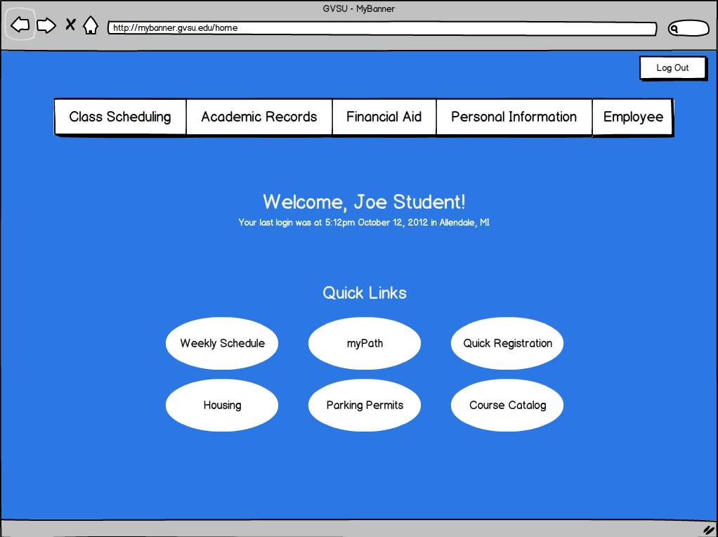

Figure 7 Drop-Down menu design

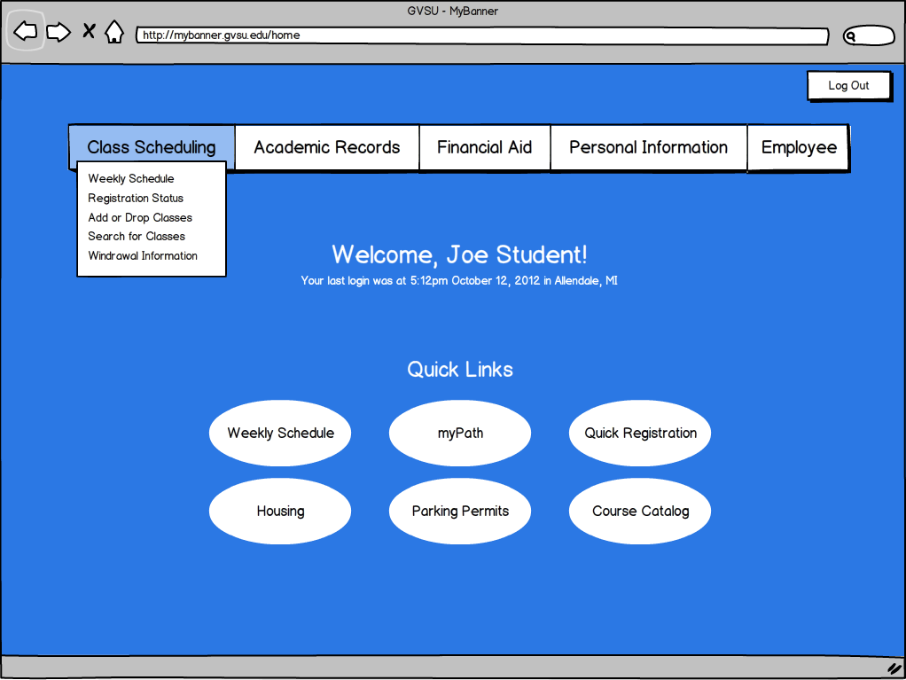

Figure 8 Drop-down menu design with a menu displayed

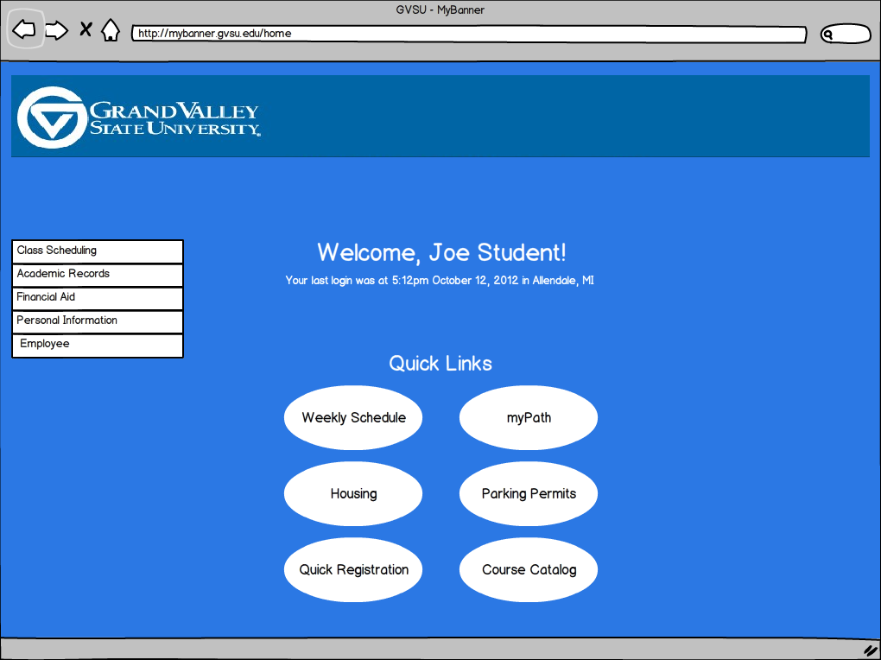

Figure 9 Accordion menu design

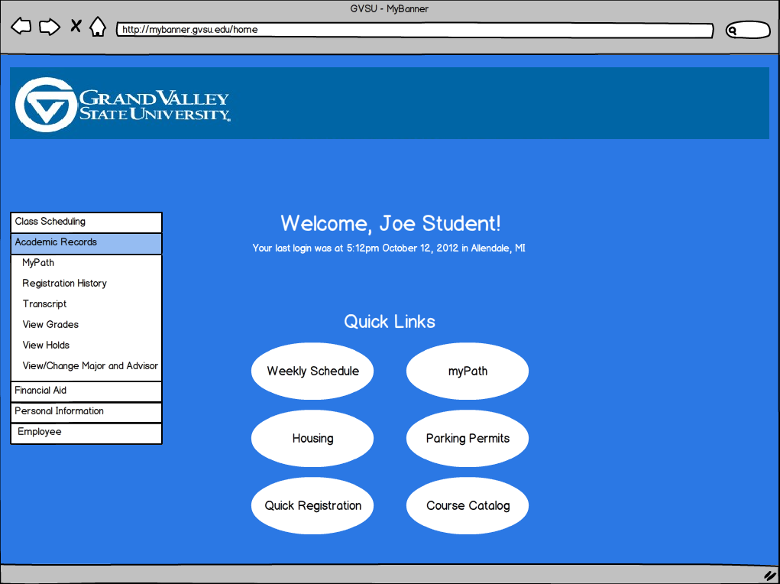

Figure 10 Accordion menu design with accordion drawn open

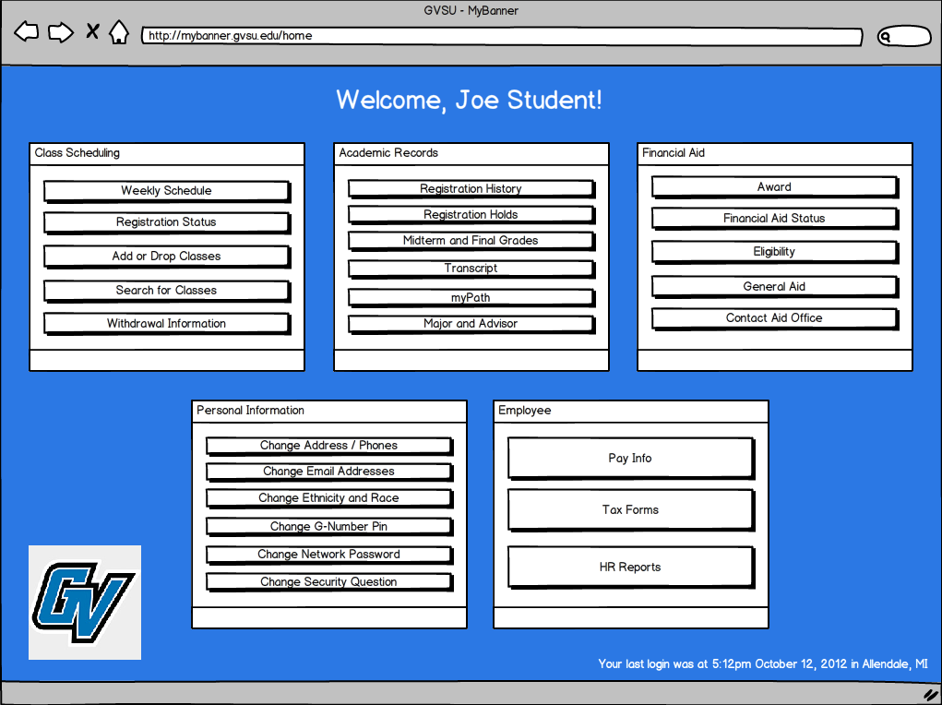

Figure 11 Windows 8 Metro "Box" design

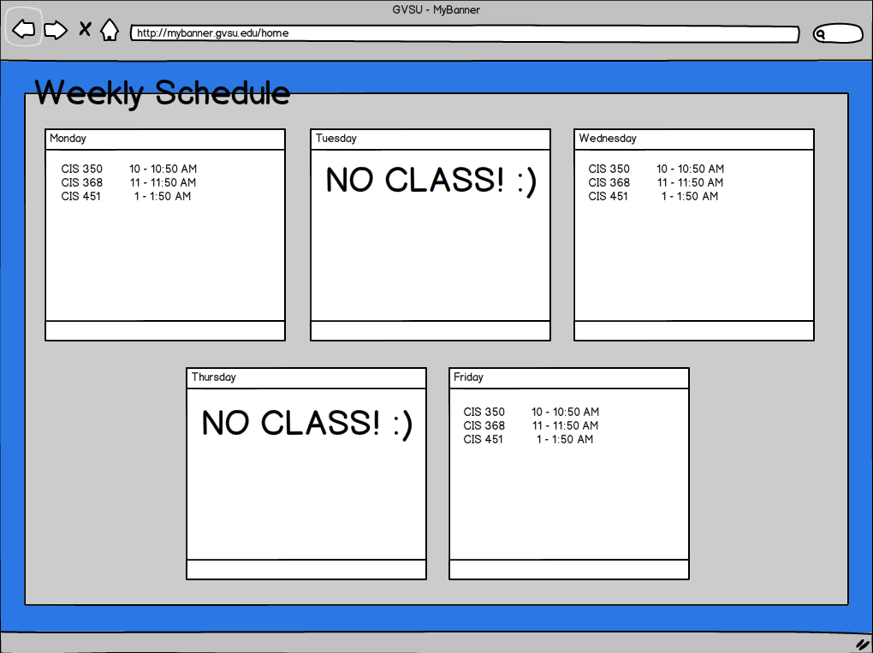

Figure 12 Windows 8 Metro "Box" design - separate page showing consistency of design.

# Design Guidelines

We researched several different sources for viable design guidelines and came up with ten different guidelines specifically tailored for BetterBanner. Specifically, most of these guidelines are derived from the Society of Technical Communication.

**Visibility**

We want to focus on creating the best website from a visibility perspective. In this regard, we need to make sure that all features/functionality of BetterBanner are clearly visible to users [2].

## Feedback

We want to make sure the user knows what is going on at all times. Through the use of feedback, we notify the user of important events and what the web page is currently doing (if it’s not apparent). This can be seen through several of our UI mockups in which we use pop-up dialog boxes to inform the user whether they’re information they entered was saved successfully, processing information, and other notifications. Although we want to display this information to the user and keep them informed, the user should not be overloaded with information. Thus, it is finding this fine balance between too much and too little information for the user.

## Navigation

Navigation is a major design guideline that we found was important for BetterBanner. We felt navigation was such an important guideline that we designed three different types of navigation for our prototype demonstrations.

## Minimizing Error Handling

During our initial testing of the current Banner system, we noticed there were several error messages users could receive that really weren’t necessary. We decided to minimize many of these errors by including more constraints in the UI. For example, if a user cannot select more than one option, we used combo boxes / radial buttons.

## Simplicity

We wanted to create a very simple, yet effective version of Banner. With many other websites following a very similar pattern of simplicity, we also felt this was a great design guildeline to use for BetterBanner. Users should be able to login and find their information as quickly as possible without extensive menus, options, and text all over the place [5].

## Consistent Design

Jakob Nielsen states in one of his Alertbox e-mails that having a consistent design throughout a website is one of the most important design guidelines to follow. This was mentioned in several areas regarding Web UI design guidelines. BetterBanner will serve students better with a design that is consistent so students can focus on the task at hand instead of trying to figure out which buttons to press. Using consistency, we decided during ideation that we should place the same types of buttons in the same location on all screens. For example, Ok/Cancel are always on the left hand side of the screen.

We also felt it was necessary to be consistent with the current GVSU website. This is evident in the way we setup our navigation on some of our prototypes. Using the drop-down navigation style, consistency is kept between the standard GVSU website and BetterBanner.

## Color

Color is another design guideline we had seen discussed in several different design guidelines. Color is very important in designing the new BetterBanner [1]. It isn’t only because we need to be sensitive about using GVSU colors, but also in order to alert users through notifications. Using red/yellow to signify error/warning allows users to easily identify a notification and its purpose. Using color in this manner allows a user to immediately determine if an action was successful or not without needing to read the text to determine any issues.

## Alignment

Another design flaw we noticed with the current myBanner system was alignment issues.As can see by the figure below, the current myBanner system has alignment issues with forms students fill out to update their personal information. Research studies show that small details make a huge difference. [4] Non-aligning text boxes and inconsistent labels are certainly a small overlooked detail.

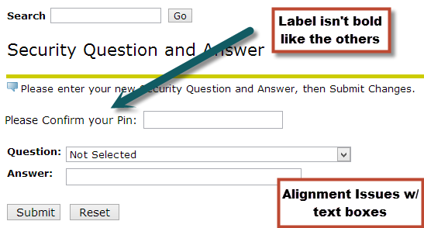

Figure 13 myBanner alignment issues.

We ended up making a better version of this screen and fixed the alignment issues with our prototypes. In fact, all forms in BetterBanner will adhere to alignment guidelines as Figure 2 illustrates.

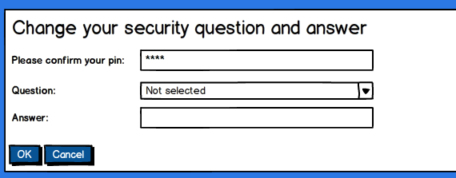

Figure 14 BetterBanner using better alignment for forms. This alignment technique is used on all forms.

## Conciseness

Another design guideline derived from Jakob Nielsen is conciseness. We use conciseness to easily illustrate our ideas without using a lot of words. For example, error messages are to the point and do not consist of paragraphs of information about what went wrong. Not being concise can confuse the user or make them not want to read the information given to them.

## Graphics / Icons

Graphics are another design guideline we wanted to follow based on our research. Graphics are very important in making sure users can easily relate to the product and information shown to them. For example, our main icon is very simple and stands out from most other icons. It is based on the color scheme we use for our overall website (again, going back to consistency) and offers enough detail for users to easily know what the icon illustrates. Students can easily determine the icon and immediately recognize it as BetterBanner.

# Formative Evaluation

Through our initial testing phases with users, we were interested in gathering data from groups of users who represented GVSU as a whole. Thus, these users needed to have a brought set of technical skills. Some users we tested had very little technical knowledge, while others (specifically in CIS 368) had much higher technical skills. Although we had to allow our professor in CIS 368 test our software, professors were not a general test market as the focus is one hundred percent on the students.

* We created these five representative tasks for our participants to complete:
* Check your weekly class schedule
* Register for a class
* Add a new phone number to your contact information
* Remove a phone number from your contact information
* Search for a class you need to take
* Check on your course withdrawal information

We felt these tasks accurately test the ability of our audience, GVSU students, to complete the most common myBanner tasks on BetterBanner.

# Early Design Changes

As with all early design phases, several changes needed to be made to the initial design. Some users immediately recognized there was not a default logout button on every page of BetterBanner. We added this feature after the initial feedback and later discussing this with each other.

We decided to go with our initial fully working mockup. This included the navigation bar that we felt was consistent across not only GVSU’s website, but also other websites as well. Students involved in the testing phase also agreed with this rationale.

One participant suggested we move the quick links to the center of the page so they are immediately seen by the user. We agreed with this suggestion because we noticed many of our participants searched the dropdown menus before noticing that certain common tasks were reachable directly from the home screen’s quick links.

Another participant suggested we remove the “Welcome Your-Name” section at the center of the screen both because it was useless information, and because most websites have your name or username near the “logout” button. We agreed with this suggestion as well to follow web consistency and avoid providing useless information to the user. This same participant also recommended we move the “last logged in” time and location security information to the bottom of the screen since this is mainly for power users.

While observing participants interacting with our personal information forms we believe we made a mistake when placing some input labels (the descriptive labels near text boxes and other form input elements) to the left of the input element. A better design would have the labels above text boxes and other input elements [2]. Users agreed this was a better design.

**References**

[1] Jakob Nielsen, *Usability of Websites for Teenagers*, useit.com, http://www.useit.com, visited 22 Oct. 2012.

[2] Fadeyev, Dmitry, *10 Useful Usability Findings and Guidelines,* Smashing Magazine, http://uxdesign.smashingmagazine.com/2009/09/24/10-useful-usability-findings-and-guidelines/, visited 22 Oct. 2012

[3] Gube, Jacob, *7 Best Practices for Improving your Websites Usability,* Mashable, http://mashable.com/2011/09/12/website-usability-tips/, visited 22 Oct. 2012

[4] Chapman, Cameron, *10 Usability Tips Based on Research Studies,* Six Revisions, http://sixrevisions.com/usabilityaccessibility/10-usability-tips-based-on-research-studies/, visited 22 Oct. 2012

[5] Jakob Nielsen, *113 Design Guidelines for Homepages*, useit.com, http://www.useit.com, visited 22 Oct. 2012.

Jordan Carney | Caleb Gomer | Jason C. Tierney | Nick Workman

Apple ink | Version: November 19, 2012



A replacement for the GVSU myBanner system.

Evaluation Plan

# Project Team Work Roles

The following is the construct of the team that worked on the high fidelity prototype of Better Banner. As a professional team, we are all fluent in every role, but distribute roles based on the project. The overall construct of this particular project was to have a manager, tester/developer hybrid, and two developers. The roles are as follows:

### Jordan Carney

Jordan’s roles include Technical Writer, Senior Prototype Tester, Senior Mac Hardware Issue Resolver, and Principal User Satisfaction Engineer.

As the **Technical Writer**, Jordan is responsible for polishing up the team’s writing to make it flow as though one person has written the entire document.

As the **Senior Prototype Tester,** Jordan is responsible for analysis of incremental prototypes and evaluating the overall potential user satisfaction of each of them. Jordan must also use Twitter Bootstrap to implement some of the changes that need to be made.

As the **Senior Mac Hardware Issue Resolver,** Jordan is responsible for dealing with Windows users’ issues with “natural scrolling”. He needs to let the user realize that Windows clunk-boxes are not a “natural” user experience in any way and that this “natural” user experience is the inevitable future -- they must accept this.

As the **Principal User Satisfaction Engineer,** Jordan is responsible for ensuring that the user is happy during their evaluation and not low on insulin in their bloodstream. Jordan will deal with this potential problem by providing sugar-laden donuts to the users for their personal enjoyment!

### Caleb Gomer

Caleb’s roles include Senior Prototype Developer, Senior User Relaxation Coordinator, Dubstep Champion, and User Experience Designer.

As the User Experience Designer, Caleb is not necessarily responsible for programming the user experience in any way, and instead should focus on coming up with good design principles that the Prototype Programmer can utilize during the actual coding phase.

As the **Senior Prototype Developer,** Caleb is responsible for utilizing Twitter Bootstrap and programmatically developing the Better Banner website. Caleb will be responsible for a large bulk of the coding and prototyping; the eventual product will be a direct result of his continued mindset and the information provided from the rest of the team.

As the **Senior User Relaxation Coordinator,** Caleb is responsible for soothing users during their evaluation of the prototype with relaxing, classical music. This ensures that the user does not feel overburdened by their evaluation of Better Banner.

As the **Dubstep Champion,** Caleb is responsible for maximizing productivity by creating melodic dubstep playlists for intense Twitter Bootstrap coding sessions! This music will be cranked to 11 and will drown out all other noise.

### Jason Tierney

Jason’s roles include **Senior Prototype Engineer, Atomic Object Fanboy,** and **User Interaction Designer**.

As the **Senior Prototype Engineer,** Jason is responsible for utilizing Twitter Bootstrap and programmatically develop the Better Banner website. Jason will be responsible for a large bulk of the coding and underlying engineering of the website.

As the **Atomic Object Fanboy,** Jason is responsible for wearing Atomic Object t-shirts and preaching how great the company is. Since he will be stating this to people living in West Michigan, they will inevitably agree and continue to boast greatly about the company. Jason is responsible for ensuring that conversations do not continue for extended periods of time as the love for Atomic Object is so great that it can potentially become counterproductive.

As the **User Interaction Designer,** Jason is responsible for designing a fluid experience for the end user by making sure the interactions feel natural. Currently, myBanner involves confusing methodologies for getting simple tasks done and Jason will ensure this type of interaction does not happen again.

### Nick Workman

Nick’s roles include **Project Manager**, **Senior Legal Manager**, **User Testing Coordinating Manager**, and **Senior Muffin Man**. 

As the **Project Manager,** Nick is responsible for coordinating deadlines and team meetings and ensuring each team member is on schedule for his required task(s). Nick will also delegate tasks for completion and subsequently check-up on their completion through email.

As the **Senior Legal Manager,** Nick is responsible for googling proper legal paperwork and printing it off. He is also responsible for presenting this paperwork to the user and ensuring that they fully understand the ramifications of it.

As the **User Testing Coordinating Manager,** Nick is responsible for presenting the prototype to the user, stating that it is not a test, and telling them to think aloud during their analysis.

As the **Senior Muffin Man** **,** Nick is responsible for bringing muffins for the group. These muffins will act as a catalyst for short bursts of productivity. These muffins are an invaluable asset to the maximal workload of the team.

# Product Description

The product description is the overall motive of this product summed up in a clear, concise statement. This one line will be engrained in the mind of everyone working on this product and will act as a driving theme for completion. It is a very general statement because we do not want to hinder creativity and present very specific ideas to the team. The product description is as follows:

*An intuitive redesign of the current myBanner website to give students better access to their important academic information.*

# UX Target Table

A **UX Target Table** is a device for quantifying user performance of our prototype. The quantitative data shown by this table analyzes what we want vs. what actually happened. We will be collecting this data during user testing. For spacing and layout, we moved the UX target table is located on the following page.

## UX Target Table

|  |  |  |  |  |  |  |  |
| --- | --- | --- | --- | --- | --- | --- | --- |
| Work Role: User Class | UX Goal | UX Measure | Measuring Instrument | UX Metric | Baseline Level | Target Level | Observed Results |
| GV Student: New user, plans for future frequent use | Intuitive for user to find and update personal information | Initial user performance | T1: Change your password | Average number of clicks before completing task | 3 clicks | 3 clicks | 5 clicks |
| GV Student: New student | Initial customer satisfaction | First user impressions | T2: Change your password | Overall impression of the usability | Good | Impressed | Mediocre |

# High Fidelity Prototype Task List

The following are the tasks that the user had to complete during evaluation of our prototype. The tasks range incrementally from simple to complex. The user will be initiated with a simple task that familiarizes them with the system and subsequent tasks will be developed from this. The benchmark tasks are also tasks that would typically be completed and are important to an everyday user. We feel these tasks are most important to focus on. We do not want to present tasks that are unimportant and useless to the user during this initial user evaluation.

## Benchmark Tasks

The following benchmark tasks were designed for users to participate in the usability study. These tasks offer further insight into how Better Banner should function and test most of the functionality of Better Banner without needing to go through every implemented task.

### T1: Log in to Better Banner

**Exact wording of T1:** “Log in to Better Banner with the G-number G1234567 and the password 1234.”

To complete this task, the user enters a G-Number and Password on the Better Banner Login screen. If the G-Number and Password are valid, the user is directed to the Better Banner Home screen. If the G-Number and Password are invalid, the user is notified of the error, and asked to repeat the login.

### T2: Change Better Banner Password

**Exact wording of T2:** “Your current Better Banner password isn’t very secure. Please change your Better Banner password to something stronger.”

To complete this task from any screen, the user selects the dropdown list in the top right corner with their name on it, and selects “Change Account Info.” The user then selects the “Change Banner Password” quick link and completes the form.

### T3: Change GVSU Network Password

**Exact wording of T3:** “After changing your Better Banner password you realize your Network password has been the same for a long time. Please Update your Network password to something new.”

To complete this task from any screen, the user selects the dropdown list in the top right corner with their name on it, and selects “Change Account Info.” The user then selects the “Change Network Password” quick link and completes the form.

### T4: View Weekly Schedule for Current Semester

**Exact wording of T4:** “View your Weekly Schedule for Fall 2012.”

To complete this task from the home screen, the user selects the “View Weekly Schedule” quick link.  
To complete this task from any screen, the user selects the “Class Scheduling” dropdown and then selects “Weekly Schedule.” Or they can use the quick link on the main page.

The user is then presented with the weekly schedule for their current semester as well as a dropown option allowing them to change semester.

### T5: Register for BIO 230, Section 01

**Exact wording of T5:** “You and a friend are both taking BIO 230 this semester. However he is already signed up for section 01, try to register before the class fills up.” For this task we included an extra note, “If a time conflict occurs please drop the conflicting class and re-register.”

To complete this task from any screen, the user selects the “Class Scheduling” dropdown and then selects “Search for Classes.” The user is presented with three search criteria: Subject, Course Number, and Section Number, the option to change the semester, as well as their current course schedule. The user types in the blank text field below the criterion or selects from a scrolling list below the text field. Once all criteria are completed, the matching course sections and times are displayed in the last scrolling list. The user selects the correct course section and then selects the “Register” button at the bottom of the form.

If it is necessary to drop a class during this process, the user selects the “Drop” button to the right of any class they wish to drop, then completes the rest of the registration task.

### T6: Check Midterm Grades for Current Semester

**Exact wording of T6:** “What was your lowest midterm grade in Fall 2012?”  
To complete this task from the home screen the user selects the “Midterm and Final Grades” quick link button.

To complete this task from any screen the user selects the “Academic Records” dropdown and then selects “Midterm and Final Grades.” The user is directed to a screen with the current semester’s Midterm and Final grades. A dropdown with the text “Fall 2012” can be used to select other semesters.

### T7: Check for Holds on Account

**Exact wording of T7:** “Do you have any Holds on your account?”

To complete this task from any screen the user selects either the “Class Scheduling,” “Academic Records,” or “Financial Aid” dropdown and then selects “Registration Status/Holds.”

The user is then presented with any holds on their account, and a statement saying whether they are eligible for registration or not.

### T8: Log out of Better Banner

**Exact wording of T8:** “Log out.”

To complete this task from any screen, the user selects the dropdown list in the top right corner with their name on it, and selects “Log out.” The user is then directed to the login screen.

## Implemented Tasks from Contextual Analysis

The following tasks have been implemented for the hi-fidelity prototype. These tasks were either present or non-existent in the original low-fidelity prototype. Further, unlike the low-fidelity prototype, each of these tasks are more dynamic in the hi-fidelity prototype.

### User logs in

The user is able to log into Better Banner with their unique GVSU account.

### User signs out

The user is able to log out of Better Banner.

### User checks grades

The user is able to view midterm and final grades of all classes for every semester they’ve taken classes.

### User searches for classes

The user is able to find and register for classes based on “Subject,” “Course Number,” and “Section Number.”

### User registers for class

The user is able to register for classes if they have the necessary “CRN” numbers or go through the class search process.

### User checks class schedule

The user is able to view their weekly recurring class schedule for any semester they have registered for.

### User removes class

The user is able to remove, or drop, any class they no longer wish to take.

### User checks registration status

The user is able to check their registration status, including any holds that may keep them from registering.

### User checks registration history

The user is able to view all classes they have registered for since they started attending GVSU.

### User views major information

The user is able to view all relevant information relating to their current major and minor, if they have one.

### User views advisor information

The user is able to view information about their advisor.

### User views transcript

The user is able to view and unofficial version of their academic transcript.

### User views holds

The user is able to check any holds on their account.

### User changes Better Banner password

The user is able to change the PIN associated with their Better Banner account.

### User changes network password

The user is able to change the password associated with their GVSU network accounts.

### User updates Address

The user is able to change their email addresses that GVSU can use to contact them.

### Unimplemented Tasks from Contextual Analysis

Due to time and scope of the project, we were unable to implement specific tasks into the hi-fidelity prototype that were present in the contextual analysis.

### User views bill

We chose not to implement bill viewing because it is only completed by students at most once per semester and would not necessarily contribute a great deal to a better user experience.

### User pays bill

We chose not to implement bill paying because it is only completed by students at most once per semester and would not necessarily contribute a great deal to a better user experience.

### User registers for parking

We chose not to implement parking registration because not every student purchases parking permits, and we wanted to focus on the features every student would use.

### User checks financial aid

We chose not to implement the financial aid section of myBanner because it is a very complicated section, requiring a great deal of information and detail. We had a hard time finding a simpler approach to it, and simpler was our goal.

### User applies for financial aid

We chose not to implement the financial aid application form of myBanner because it is a very complicated form, requiring a lot of user input and it had little room for simple improvements.

### User declares major(s)

We chose not to implement the major declaration function of myBanner because the average student uses this very seldom.

### User declares minor(s)

We chose not to implement the minor declaration function of myBanner because the average student uses this very seldom.

### User changes major

We chose not to implement the major changing function of myBanner because it was the same as the major declaration section.

### User checks schedule for month

We chose not to implement a month view for the user’s class schedule because there is no difference in each semester’s class schedule from week to week or month to month. It would only display the same information for every month.

### User exports schedule to iCalendar / Outlook

We chose not to implement the calendar export feature because we did not believe students would find the feature on myBanner.

### User requests formal/printed transcript

We chose not to implement the formal printed transcript feature for myBanner because we did not have access to the correct resources to accomplish it.

### User sets up meeting with counselor

We chose not to implement the counselor meeting feature because we did not feel students use myBanner to schedule these appointments.

### User updates phone

We chose not to implement the phone update feature of myBanner because it was the same user interaction as updating an address and we chose to focus on other user interactions instead.

### User updates e-mail

We chose not to implement the email update feature of myBanner because it was the same user interaction as updating an address and we chose to focus on other user interactions instead.

### User views ethnicity / race

We chose not to implement the ethnicity and race update option of myBanner because we did not feel it made much sense for it to be there in the first place.

### User updates security question

We chose not to implement the update security questions feature because we felt that users did not use this feature enough to warrant creating and testing a better version.

# Screen Shots

The following screenshots provide a generic overview of Better Banner. They do not show the entirety of the website, but they show the important features of the website and the general functionality. Among screenshots, you should notice consistency as this is the important user experience principle. It is also important to note that GVSU’s color scheme is blue and white -- you will notice that consistent color scheme throughout the website.

## Screenshot Analysis

In this section we will analyze each of the screenshots we have built for the hi-fidelity prototype.

Figure 1 shows the simple Better Banner login system. There are two important differences to notice from the current myBanner system: the length of the input fields and the “remember me” checkbox. The length of the inputs fields on the current myBanner are different sizes -- we fixed this simple inconsistency. The “remember me” checkbox offers easier access to frequent myBanner users because nobody wants to constantly input their G-Number and password. Also, pay particular attention to the color scheme and layout as you will see this in subsequent screenshots.

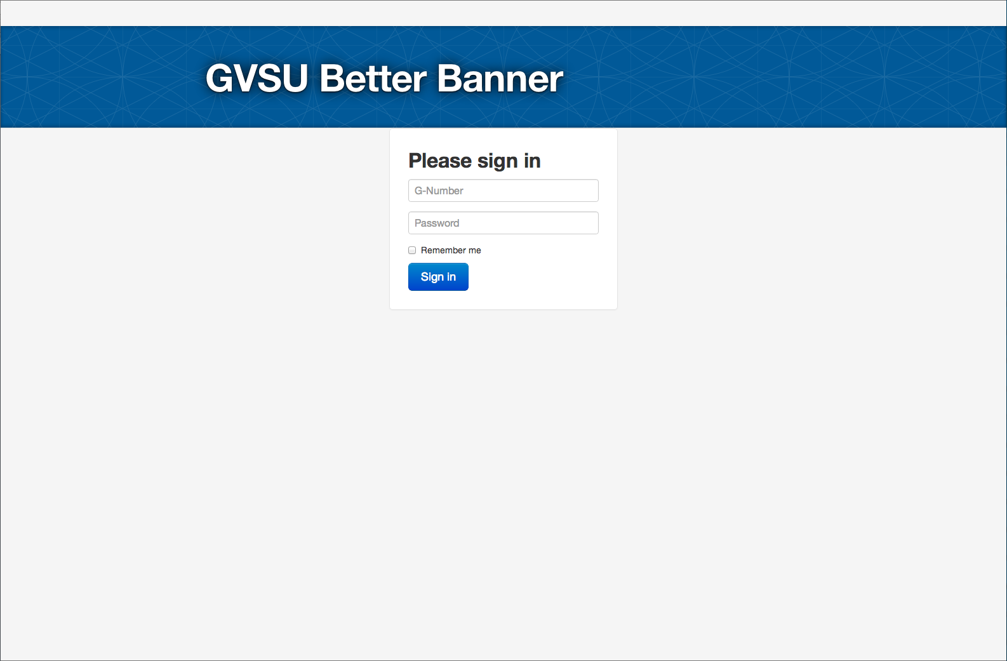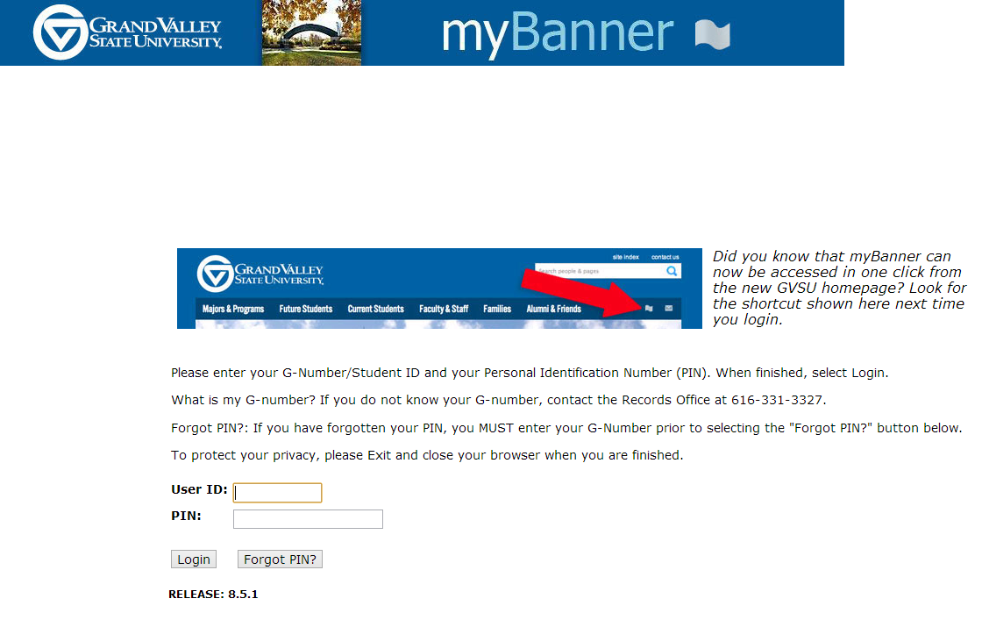

**Figure 1:** Better Banner login page (top) compared with the current myBanner login page (bottom).

Figure 2 shows the Better Banner home page. The first thing the user will notice is the giant text saying “GVSU Better Banner: myBanner done right”; this is intentional. We know that users have become fluent in using the influent myBanner and we want to differentiate from that immediately. We want the user to know that this is going to be a much better experience. The second thing the user will notice is the existence of quick links. We have come to realize that most users of myBanner do a few simple tasks and don’t use myBanner for anything else. We wanted to make these few simple tasks simpler.

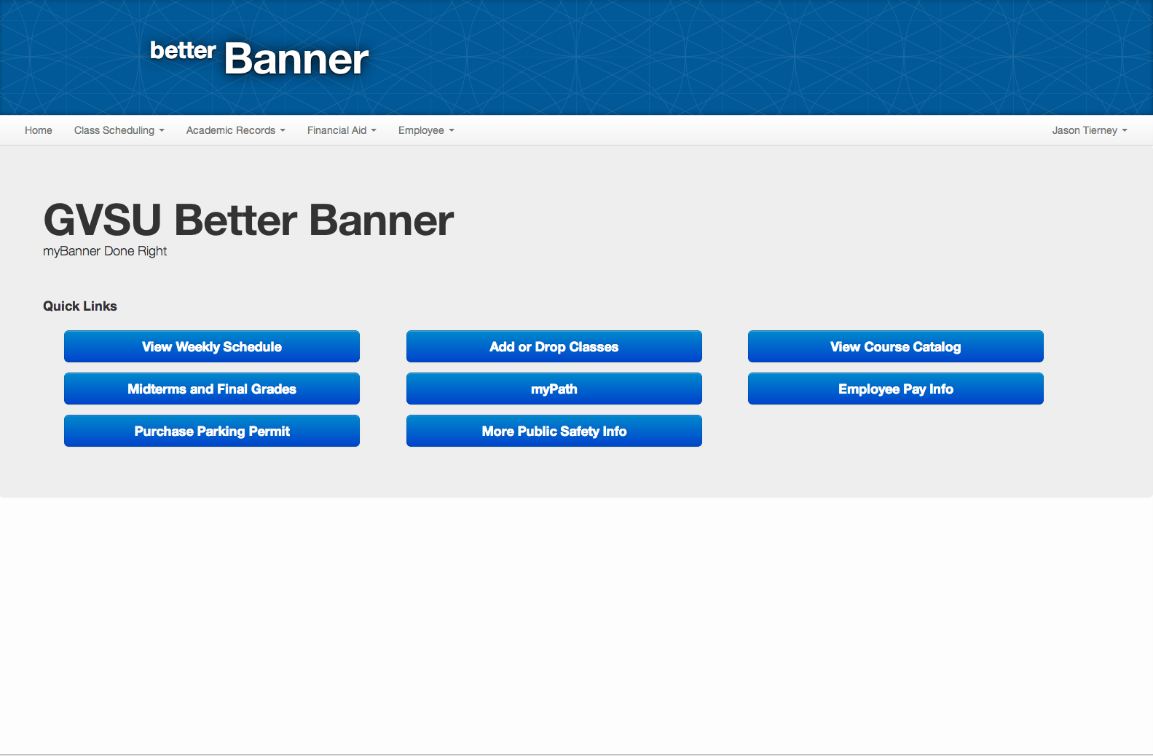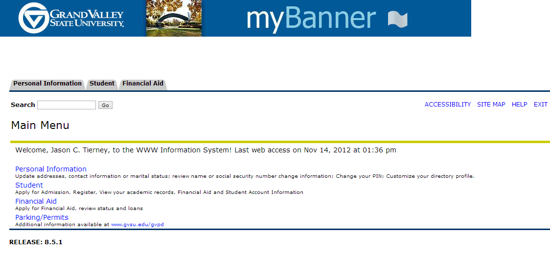

**Figure 2:** Better Banner homepage (top) compared to myBanner’s home page (bottom).

Figure 3 shows the drop-down menu system we developed for Better Banner. This navigation bar holding the drop-down menu is static and consistent throughout the entire experience. A major problem with myBanner was an unclear navigation system -- we developed this navigation system to deal this unclear navigation.

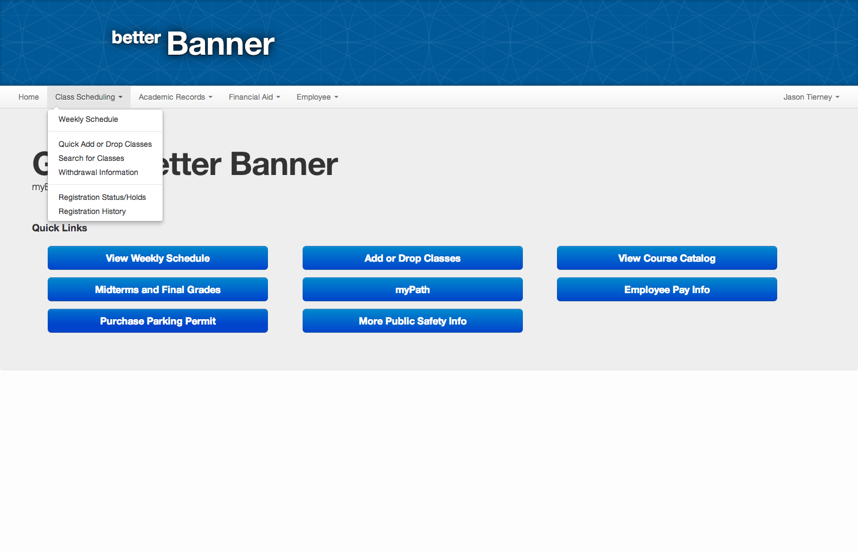

**Figure 3:** Better Banner drop-down menu system. myBanner does not implement this solution, thus we cannot provide a comparison screenshot.

Figure 4 is included to show the generic content view that will be recurring throughout the website. Notice the gray horizontal sections encasing information and the header section containing a semester combo box.

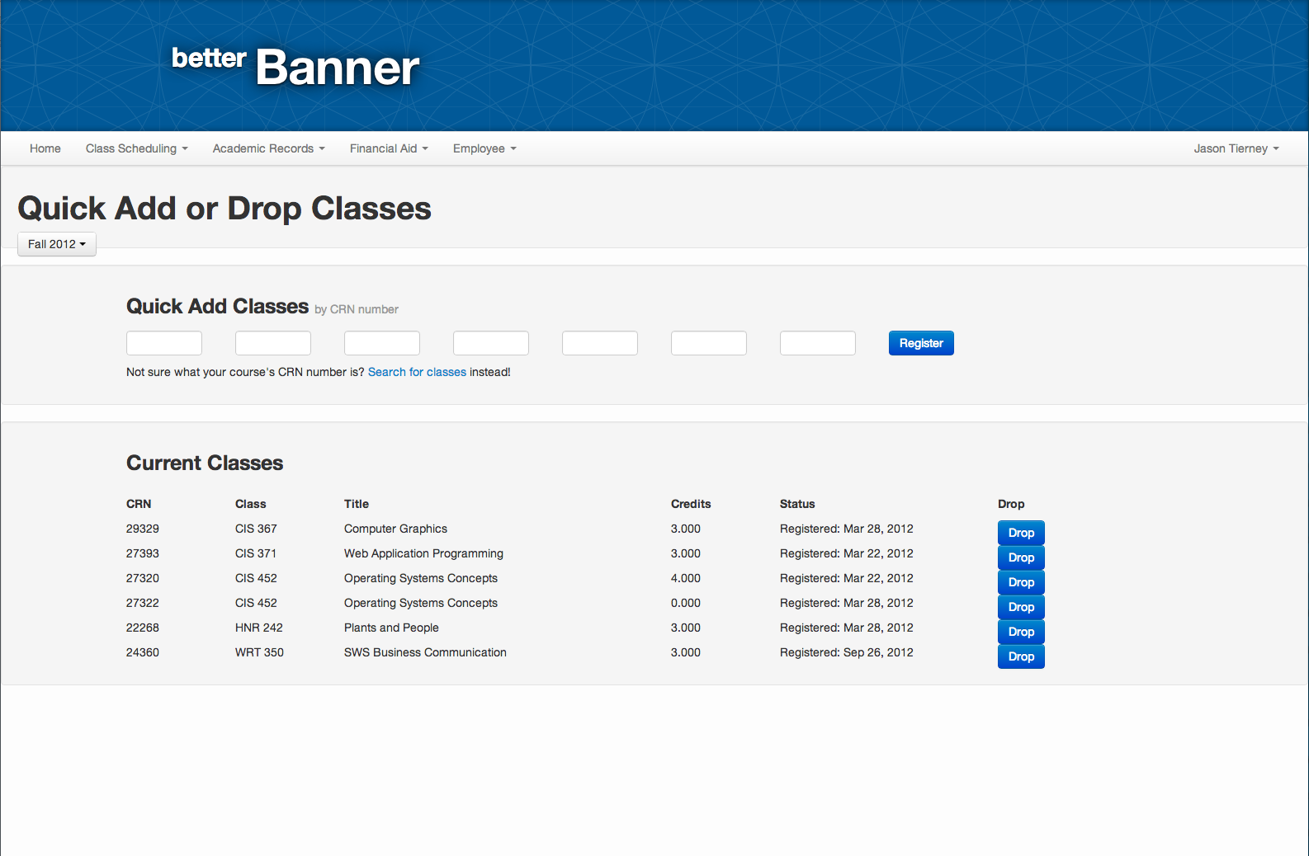

**Figure 4:** Better Banner generic content view

# Video Demo

We created a demo video of BetterBanner that lasts for about six minutes in length.

Link to screencast: <https://www.dropbox.com/s/vy2g6wsi7bqqj7r/BetterBanner.mov>

The link above is a screencast overview of the Better Banner website. In the video, I overview a lot of the general content on the website. I explain the advantages of Better Banner over myBanner and elaborate on particular design decisions we as a team made. The video does not go through every page of the website, since that would consume a considerable amount of time, but it does explain all pertinent information regarding the usability and user interaction of the website.

The screencast was made with the default Quicktime screencast tool on Mac OS X.

# Design Highlights

This sections serves to point out design elements we as a team were particularly proud of. This section will not discuss basic design elements, but instead will focus on a few important design constructs. We feel this particular design constructs were essential to the success of our website. These design highlights will also focus on the improvement they are from the current myBanner system.

1. **Simple, elegant layout**

The current myBanner system has an incredibly ugly layout and the important information myBanner has low levels of readability because of the layout. If you look at any of the figures above, you will notice that the layout was designed to be easily readable. The one purpose of myBanner (and Better Banner now) is to present information and we wanted that information to be presented elegantly and with high levels of readability. The main factor that increased the level of readability on Better Banner was organization and consistent text sizes.

2. **Static Navigation System**

When using the current myBanner, we noticed that navigation was never consistent and the user had to navigate back to a page in order to get to a different page. We wanted all pages to be accessible from any location on the website. Thus, we created the intuitive navigation bar as seen in Figure 3. We also noticed that users had very few tasks they needed to actually complete on myBanner, so we created quick links that would allow them to navigate to those pages in one click (see Figure 2).

3. **Consistency**

The current myBanner system greatly lacks consistency. The user never knows what to expect because the outcome of actions always seem different! We wanted to alter this and implement a standard cause and effect chain where effects are always dependant on what caused them -- not a completely random variable. Consistency is also lacking in the design of the current myBanner. Different views on myBanner have different constructs instead of a generic content view (see Figure 4) like Better Banner is implementing. For every new view the user sees, we do not want them to have learn about it, we simply want them to learn one general construct and be on their way.

# Evaluation Plan

The evaluation plan is used to figure out the goals and purpose of the evaluation, the participants in the evaluation plan, how we recruit, the environment in which we want our participants to participate in, the procedures or questions we want to ask the users, and the type of data we want to collect during the evaluation. This evaluation plan should be able to be presented to an outside consultant without them needing to ask much more information regarding how we want to evaluate our users.

This evaluation plan will focus on the post hi-fidelity prototype that we made changes to after demoing to roughly 8 – 10 users. This evaluation plan also reflects the changes we have made since the hi-fidelity prototype in order to get more user feedback about these changes.

## Goal and Purpose

The goal of this evaluation plan is to determine how easy and usable the improved hi-fidelity better Banner is compared to the current myBanner. We are not testing all of the new Better Banner features and functionality that will replace the current myBanner, but instead are focusing on a few features that we believe cover the majority of the use of the current myBanner system. The features evaluated in this hi-fidelity prototype include:

* Logging in and out of Better Banner.
* Checking both midterm and final grades.
* Changing personal information
* Changing password
* Searching for classes
* Signing up for classes.

For a full list of tested functionality, please refer to the section on Implemented Tasks from Context Analysis. Although we have a large feature set with this test, we have eight specific tasks we would like users to complete that we believe adequately test the majority of the functionality of Better Banner.

To go along with our feature set, there are also several UX goals and targets we would like to track throughout this usability study. We would like to see, from a usability perspective, if the following goals are met:

* Overall ease of use of the site
* Is the navigation smooth, intuitive, and understandable to the user?
* How does the overall layout of the site appeal to users?
* Video capture of the user in order to record his/her spoken thoughts throughout the process.

The types of data we would like to collect is both qualitative and quantitative. The data will range from determining whether users are able to finish their given tasks, users evaluating (on a number scale) the ease of use of each task, and some qualitative data of the user given verbal feedback to the data collectors and facilitator.

This evaluation should not be treated as a final progress evaluation of the system. We are currently in the process of designing and this stage fits the hi-fidelity point of the design process.

## Team Roles

We would like to have four different team roles for the evaluation team for this usability study. These roles include the following:

* **Facilitator.** This role will lead the evaluation team in making sure everything is accomplished as stated in this evaluation plan. Further, they will also be in charge of communicating to the user how the usability test will be done.
* **Data collectors.** Due to the nature of this project, we believe there should be two data collectors. One data collector focuses completely on the quantitative data. The other data collector will focus on collecting the qualitative data. In this role, the collector will work with the user and ask him/her questions about how they felt the overall process was for his/her given task.
* **Supporting actor.** The supporting actor will help coordinate each task to the user. This will involve letting the user know what the task is and the purpose of the task.

## Participants

The participants for this evaluation plan should only include students from Grand Valley State University. Future studies may be done with transfer students or high school students, but this study should focus completely on GVSU students only. We would like to have 25 students participate in this usability study of Better Banner. These participants should have a diverse background with different degrees, class status, and involvement in organizations. We will also need to make sure both traditional and non-traditional students are included in the study. However, we should not include too many non-traditional students in the study as they do not completely represent the student body. We are thinking about 3-5 students should be non-traditional students. Participants should be notified that the study should not take more than 30 minutes.

We would like to pay the participants with a $25 VISA gift card. The total cost for this should be $625 ($25 * 25 participants). In addition to the twenty-five standard students, we would also like to recruit five additional “expert” students. These students will need to qualify for being “experts” with myBanner. Participants who believe they are experts will take a brief quiz about the current myBanner and based on those who have the highest score and further match the criteria stated above, we will select five students to be our expert users. These users will be used to determine how the power users would normally use myBanner and if there are certain features in our current hi-fidelity prototype that may be broken from the current myBanner. Incentives to recruit these students are the same as normal students. A $50 VISA gift card. This would bring the total incentive cost to $875.

In order to get the word out to students to participate, we plan on sending out e-mail invitations, flyers around campus, and word of mouth. Students will be able to sign up on an online system to register to be a participant. From this online system, twenty-five users will be selected based on the above criteria.

## Environment

We would like to have a very safe, secure, and relatively quiet environment. When we refer to safety and security, we simply mean we would like our users to feel at ease and stress free while taking the usability test. There should only be one participant in a room at a single time. A small conference room that holds five people should suffice. This room should include the facilitator, the two data collectors, and the supporting actor. However, the data collectors should not interact as much with the user throughout the study and should be more viewers than participants.

For equipment purposes, we require a laptop with a minimum Core 2 Duo (or equivalent) processor, a 15 inch screen or larger, and an external mouse. The Better Banner website will be hosted on an external server, so an Internet connection will also be required. This connection can either be wired or wireless, but it must be reliable for the test to be successful. As we will be recording users during the test, we will also require a video camera. This video camera can either be attached to the laptop or external.

## Procedures

This section discusses the different procedures that each participant will follow for his test. Every participant will use the same procedures for each test. Procedures include welcoming statements, test scenarios, informed consent forms, and possibly non-disclosure agreements, if needed. These documents are included in the appendix section of this document and are briefly discussed in this section.

### Welcome Dialog

Every participant should be given the same (or very similar) welcome dialog. The exact phrasing does not need to match the welcome dialog presented in the appendix exactly, but it should adhere to it as close as possible. The purpose of this welcome dialog is to discuss with the user the purpose of the test, that they are not being test (the software is), and that the information collected will be used in a final report. If participants do not wish to have their information collected, we may still perform the usability test, but their data cannot be used.

### Informed Consent Form

Every usability participant will be given an informed consent form. This form is included in the appendix for use with participants. Every participant which we use data for must sign this form in order for his/her data to be included in the report. It is vital that we make sure users sign this form and give us permission to use their data before we actually present it in the data analysis and final report.

### Test Steps

The user will be presented with eight user tasks. These tasks try to represent typical use of the Better Banner system to the best of our ability. The following tasks we will present the user are as follows. (Note: these are also included in the appendix with further information.

1. Log into Better Banner with the GNumber g1234567 and the password 1234.
2. Your current Better Banner password isn’t very secure. Please change your Better Banner password to something stronger.
3. After changing your Better Banner password you realize your Network password has been the same for a long time. Please update your Network password to something new.
4. View your Weekly Schedule for Fall 2012
5. You and a friend are both taking BIO 230 this semester. However he is already signed up for section 01, try to register before the class fills up.

NOTE: if a time conflict occurs please drop the conflicting class and re-register.

1. What was your lowest midterm grade in Fall 2012?
2. Do you have any Holds on your account?
3. Log out of Better Banner

Each of these tasks are included in the task data collection form provided in the appendix. This form will include task completion and evaluator comments regarding how the user went about completing each task or why the user failed completing a task. How this form is used in collecting data from the user is discussed in more detail in the Data Gathering section.

### End of Participant Study Results

At the end of the study, each participant will receive a brief survey of five questions. This survey will help with analyzing the overall opinions users have about the Better Banner system. This survey is included in full text in the appendix section and is discussed in further detail in the Data Gathering section.

## Data Gathering

Data is very important for this usability test. In order to make sure we accurately collect user information, we want to make sure that the data we collect accurately represents users’ feelings towards Better Banner.

### Collecting the Data

Every task will include the same type of feedback in order to maintain consistency between tasks and participants. These results should be stored in an Excel spreadsheet. An example template of this spreadsheet is provided in the appendix. This form helps evaluate the task and user’s ability to complete the task. Each task is given a success/failure column as well as an evaluator’s comments column. The former of these two columns should only contain a simple Yes/No answering whether the user successfully completed the task. The latter column should contain comments that the evaluator makes regarding how the user went about completing each task. If the user failed to complete the task, the reason should be noted in this column.

The following questions should be discussed at the end of every task. Some of these will be included in the task data collection form, while others are to be completed in the end of study survey.

* Did the user successfully complete the task? (Simple Yes/No - Quantitative)
* Evaluator comments on user completion of tasks. (Qualitative)
* User comments on ease of completing the task. (Qualitative)
* User rating of ease of completing the task on a scale of 0 - 5 (0 = did not complete, 5 = easy to complete).

At the end of each participant study, we will have a survey (the full text version of this survey is included in the appendix section). This survey will allow users to further evaluate the Better Banner experience and let us know what they believe was good, bad, better, or worse than the current myBanner. These questions are more on the qualitative side of the data collection. However, they also provide insight as to how the user feels about the overall experience of Better Banner, specifically in regards to the current myBanner.

### Summarizing and Analyzing the Data

We would like all of the data to be summarized and analyzed in a manner that will give us real world results when moving up from the hi-fidelity prototype. This section covers how we would like the data to be summarized and analyzed for this evaluation. It is crucial for the data to be properly analyzed in order for this evaluation to be a success.

Data should be summarized in order to determine the overall success of both participants and tasks in general. We would like to have an average, median, and mode of each feedback question at the end of each task. Further, each task should be rated based on its level of success. We would like to have all of this data summarized in an Excel spreadsheet or similar format. We provide some examples of the data we want to collect and how we want it summarized below.

**Success of Participants.** The success of participants completing the individual tasks is recorded as raw data under the task success column in the data collection form. We would like this data to be summarized by each task with the following information for each task:

* Mean and Median of the data.
* Ordered by highest number of completion to lowest number of completion.
* Outliers in regards to participants – were there any participants that just seemed to not be able to accomplish a specific task while others were able to without any trouble?
* Task outliers – were there any tasks that seemed like most users could not accomplish?

**Evaluator Comments on Tasks.** This section of data defines the more qualitative data that we are collecting. This data is collected on the data collection form in the task comments column. This should not be confused with the comments users make in the post-study survey. In regards to comments for each task, we would like to have this data summarized as follows:

* Do not include redundant tasks – instead add a counter to each task depending upon how many users made a similar comment.
* Sort out outliers. If there are any outliers in the comments, such as “user could not figure out how to change a password” where many users were experiencing this issue, we would like these noted.

**End of Study Participant Surveys.** This section of data includes all of the questions and responses to the survey participants take at the end of the study. The following provides examples of how we would like data to be summarized for this section:

* Do not include redundant comments. If there are multiple similar comments, please instead include a count of these comments in the summary.
* Include a mean and median for the 1, 2, and 4.

After the data has been collected and summarized, we will need to analyze the data appropriately in order to get conclusive results. We would like to analyze the data in order to determine whether we have produced a successful hi fidelity prototype. This may include whether tasks have been determined to be overall easy to complete for the average user, whether the data was accurately predicted from the beginning. As with the summary of data, we would like the data analysis to be broken up into similar categories. These three categories are explain in detail below.

**Success of Participants.** After looking through the summary of the data, we should start to look at specific tasks and figure out possible reasons users were unable to complete these tasks. For example, was the option not in the navigation bar?

**Evaluator Comments on Tasks.** Looking through these, we should be able to determine any outliers from the summarized data and come up with some analysis of why the outliers existed.

**End of Study Participant Surveys.** Again, what do the outliers represent in the surveys collected from the users. Are there any major issues that need to be addressed before a more final version of Better Banner is created?

Jordan Carney | Caleb Gomer | Jason C. Tierney | Nick Workman

Apple ink | Version: November 19, 2012



A replacement for the GVSU myBanner system.

Results

# Evaluation Results

This section goes over the results of our evaluation of the Better Banner hi-fidelity prototype. Our results will include raw data, summarized data, and an analysis of this data within the scope of our prototype.

### Rough Data

The following data was collected throughout a evaluation period. We had a total of eight (8) participants use the Better Banner hi-fi prototype. The results gathered will help further the design of Better Banner and make it into a more usable and well thought out product in the end.

During our evaluation period, we did make some changes to the UI based on feedback from the early evaluators. These evaluators noted specifically that it was difficult to change their network password and they were confused with the ‘holds’ section. The data below reflects these changes and is categorized based on the changes made to the UI.

#### Task 1: Log in to Better Banner

|  |  |  |
| --- | --- | --- |
| **Participant** | **Successful completion?** | **Comments** |
| 1 | Yes | No problems |
| 2 | Yes | Expected the return button to work. |
| 3 | Yes | Using ‘Enter’ to log in would be nice |
| 4 | Yes | No problems |
| 5 | Yes | “Very easy” |
| 6 | Yes | “Easy” |
| 7 | Yes | Easy, but would like cursor in username first |
| 8 | Yes | “Easy” |

Overall, logging into Better Banner was an easy task for every user. Some users, however, did note that they would like some feature enhancements, such as:

* Making the username field the default field when users first launch the log on page.
* Allow the return/enter key to function as logging them in after the user has entered in his/her username/password.

#### Task 2: Change Banner password

In this task, the user was supposed to navigate through Better Banner and change his password for Banner.

|  |  |  |
| --- | --- | --- |
| Participant | Successful Completion | Comments |
| 1 | Yes | “This is slick!” |
| 2 | Yes | Checked everywhere before finding it. (All quick links and dropdowns.) Eventually found dropdown for name to change the password. |
| 3 | Yes | Expected to return to home page. Didn’t feel right to have to click “home” afterwards. |
| 4 | Yes | “That was nice” |

After changing the location of the password, we had much better results from users.

|  |  |  |
| --- | --- | --- |
| Participant | Successful Completion | Comments |
| 5 | Yes | Easy |
| 6 | Yes | He found it right away (YAY!) |
| 7 | Yes | Easy |
| 8 | Yes | Stumbled around for a while, found dropdown, saw password link. |

Although in both versions users were able to successfully complete the task, after making these slight changes overall usage feedback was very positive compared to the original design. However, there was still one user who had a little bit of a hard time finding it. This user could have been an outlier.

#### Task 3: Change Network Password

In this task, the user needed to change his network password. The network password varies slightly from the Banner password and is used to log in to other services on the school’s network. As with the previous task, we made some changes to the UI to accommodate users better for this task.

|  |  |  |
| --- | --- | --- |
| Participant | Successful Completion | Comments |
| 1 | Yes | Found it through the quick links |
| 2 | Yes | Repeated search process as last task before finding **Personal Information -> Change Network Password**. We should merge into the same thing. |
| 3 | No | Checked username background, then employee, then quick links. Could not find it. |
| 4 | Yes | No comments |

As noted in the previous task, after initial user feedback, we redesigned how users go about changing their password. After this redesign, users had an overall better experience with trying to change their myBanner password. The results below for the next four users shows that every user was able to change his password. These users also had an overall better experience based on the qualitative feedback they provided.

|  |  |  |
| --- | --- | --- |
| Participant | Successful Completion | Comments |
| 5 | Yes | Easy |
| 6 | Yes | The change myBanner password shows success and stays on screen, however change network password returns to person info page. |
| 7 | Yes | Easy. Would like a confirmation. |
| 8 | Yes | Repeated last process to accomplish this task. |

Some things we believe would further improve the usability would be to give confirmation of changing the password and return the user back to the personalization screen.

#### Task 4: View Weekly Schedule for Fall 2012

In this task the user was requested to view his weekly schedule for the current fall semester. This task was viewed by most users as a fairly simple and easy task to accomplish. There were no changes made or required based on user feedback for this task. The following data shows the different users we surveyed, the successful completion of each task, and the user’s comments.

|  |  |  |
| --- | --- | --- |
| Participant | Successful Completion | Comments |
| 1 | Yes | Class Scheduling → Weekly Schedule |
| 2 | Yes | Used quick link! |
| 3 | Yes | “Lots of choices” |
| 4 | Yes | N/A |
| 5 | Yes | Used dropdown |
| 6 | Yes | Used dropdown |
| 7 | Yes | “Easy”, Used dropdown |
| 8 | Yes | “Easy”, Used dropdown |

What we learned from this task was that users were more keen to use the dropdown menu to find their weekly schedule than use the quick link we provide on the home screen after they login. Given that users were new to this system, this process may have been the most logical based on other similar systems they have used in the past. We believe that after the user realizes the quick link is there, they will continue using it instead of the dropdown menu.

#### Task 5: Register for a class

In this user task we asked a user to try to register for a specific class for the current semester. The process also entailed placing the user in a predicament of also dropping a course due to a time conflict with an existing course in his schedule. Although one user was unable to actually complete this task, we believed this user was an outlier based on positive feedback from other users.

|  |  |  |
| --- | --- | --- |
| Participant | Successful Completion | Comments |
| 1 | Yes | Class scheduling → Quick add/drop |
| 2 | No | Used ‘course catalog’ button and got lost |
| 3 | Yes | Used quick link for quick add, eventually found ‘search for classes’ link. Didn’t want to have to re-enter info after dropping a class. |
| 4 | Yes | Nice and easy. It was nice that it was all one screen. |
| 5 | Yes | “Not too hard.” |
| 6 | Yes | Wanted a confirm drop class popup. |
| 7 | Yes | Shouldn’t get rid of selections after dropping class. |
| 8 | Yes | Didn’t like the reset on data entered. |

#### Task 6: Find your lowest grade for the current semester

In this task, we asked the user to try to find his lowest grade for the current semester. Overall, this task received well reviews from users and was an easy task to complete.

|  |  |  |
| --- | --- | --- |
| Participant | Successful Completion | Comments |
| 1 | Yes | Easy |
| 2 | No data | No data |
| 3 | Yes | N/A |
| 4 | Yes | It was nice. The most used link was at the top of the dropdown menus. |
| 5 | Yes | Via dropdown |
| 6 | Yes | via dropdown |
| 7 | Yes | “Easy”, via dropdown |
| 8 | Yes | Used quick links |

User two was unable to to accomplish this task due to time constraints. However, the rest of the users seemed very pleased with the task. Most users used the dropdown menu bar, while two users ended up using the quick links on the home screen. Based on this data, we decided not to make any major changes to this process.

#### Task 7: Check for any holds on your account

In this task, we asked the user to check for any holds on his account. All users were able to complete this task; however, some users were unsure of the types of holds, academic versus financial. The following table summarizes user success and comments.

|  |  |  |
| --- | --- | --- |
| Participant | Successful Completion | Comments |
| 1 | Yes | Should have holds option under financial aid |
| 2 | N/A | N/A |
| 3 | Yes | Should have link from financial aid section. |
| 4 | Yes | First thought holds was under financial aid |
| 5 | Yes | “Easy” |
| 6 | Yes | N/A |
| 7 | Yes | Didn’t know what holds were |
| 8 | Yes | via dropdown |

#### Task 8: Log out of BetterBanner

|  |  |  |
| --- | --- | --- |
| Participant | Successful Completion | Comments |
| 1 | Yes | It would be cool if it were an icon. |
| 2 | No data | No data |
| 3 | Yes | Doesn’t like the “log out” under the name dropdown |
| 4 | Yes | N/A |
| 5 | Yes | “Easy” |
| 6 | Yes | “Easy” |
| 7 | Yes | “Easy” |
| 8 | Yes | “Easy”, “I wish this was how myBanner was” |

### Brief Summary and Analysis of Data

Of the eight users who evaluated Better Banner, we found all of them to be overall impressed with the system. Each user thought the UI was much better than the current myBanner system and were impressed with the changes we had made. With that said, we did have several evaluators who still had issues doing simple tasks. Most notably, we noticed users had a very difficult time in changing their password.

# Design Changes - Part 2

This section reflects the design changes we will implement between our first hi-fidelity prototype and our next prototypes of Better Banner. As with all prototypes, many changes are encountered when it is put through an evaluation period. We had several people evaluate our prototype and from the results we plan to implement several changes we hope will make the experience of Better Banner even better.

# Conclusion

If we implemented our new design changes and had another go around with our prototype with both new and previous evaluators, we believe we would make more design changes, but definitely not as many as in previous prototypes.

Jordan Carney | Caleb Gomer | Jason C. Tierney | Nick Workman

Apple ink | Version: November 19, 2012



A replacement for the GVSU myBanner system.

Appendix

## Previous Team Roles

Between Projects 1 and 2 we left the team roles relatively unchanged. However, Project 3 we decided to shake things up a bit. Below are the team roles for both Projects 1 and 2.

### Jordan Carney

Jordan’s roles include **Technical Writer** and **UX Designer**. As a technical writer, Jordan is responsible for polishing up the team’s writing to make it flow as though one person has written the entire document. As the lead UX designer, Jordan takes charge of designing a very usable and fluid user experience for students accessing myBanner. As the designer, Jordan is not necessarily responsible for programming the user experience in any way, and instead should focus on coming up with good design principles that the Prototype Programmer can utilize during the actual coding phase.

### Caleb Gomer

Caleb’s roles include **Lead Graphic Designer** and **Lead Tester**. As the lead graphic designer, Caleb dictates how the graphical user interface should appear to the end user. This comes down to the colors, CSS styling, fonts, and images/icons used for the end product. As the lead tester, Caleb is responsible for making sure the product has use cases and unit tests that can adequately test the product during integration testing for any defects before it goes out the door.

### Jason Tierney

Jason’s roles include **Technical Lead** and **Prototype Programmer**. As the technical lead, Jason is responsible for making sure all technical aspects of the project flow together. As the prototype programmer, Jason is responsible for producing a usable prototype for demonstration purposes. At a minimum, this role requires some UI coding and possibly mockup backend coding to demo the UI.

### Nick Workman

Nick’s roles include **Senior Project Manager** and **User Interaction Designer**. As the project manager, Nick is responsible for coordinating deadlines and team meetings and ensuring each team member is on schedule for his required task(s). As the user interaction designer, Nick is responsible for designing a fluid experience for the end user by making sure the graphics designer and UX designer work together in a coherent manner.

## Team Rules

We decided on the following rules for our team:

* If a member misses a meeting without an excuse we address this in our team evaluations.
* Group meeting every Friday - every member must attend, unless an unforeseen circumstance occurs. These meetings are used to brainstorm/start working on projects/as status meetings to see where everyone stands. Thus, these meetings are vital for every group member to be present. To facilitate brainstorming, f’real shakes are mandatory at every meeting.
* Must use Microsoft Word to format documents. (Google ~~Docs~~ Drive SUCKS!)



# Informed Consent Form

Welcome to the Better Banner usability study! We thank you and appreciate you taking the time to try out the latest Better Banner system which may soon replace the current myBanner. Before you begin the evaluation portion, we would like to state some information regarding the use of your data, your rights to that data, and the type of data collected. We would also like to point out that there are no foreseeable risks involved in completing this usability study.

As a participant of this usability study, you will receive a $25 Visa gift card. This gift card can be used anywhere that Visa cards are accepted. This is the only compensation you will be given for completing this usability study. If you are designated as an expert user, you will be provided a $50 gift card. However, you only get one of these two payment options, not both.

In regards to the data we collect about you. All of the data is collected anonymously and we will not share the data without your explicit consent. Your consent for sharing this data is your signature at the bottom of this form. With your consent, we will include your anonymous data into a final usability report on Better Banner. Your data will not be shared with any other third party and will only be used in the report. Again, we would like to point out that all data is collected anonymously and your name, nor any other identifying information, will be used to identify you.

Throughout the usability study we may record you to get your feedback about the process you go through to accomplish the steps. This data will not be released to any third-party and will only be seen, accessed, and used by those directly involved in this usability study. If we do intend to use this video for any other purpose, we will ask you for permission and only use it with your permission.

If you agree to these terms, please write your name and sign below. Thank you, and again, we appreciate your time in evaluating Better Banner.

**The Better Banner Team**

Printed Name

Signature / Date



# Standard Welcome Dialog

**Every user should be given a standard welcome dialog that follows the following format. Note, the welcome dialog does not have to match word for word, but should include most of the common elements.**

Welcome to the Better Banner usability experience study! We hope you will enjoy yourself while you try out the new Better Banner system which may replace myBanner in the future.

We would like to remind you that although this is a “test” we are not testing you, but are instead testing the software we have created. Feel free to try to break it, play with it, and use it like you normally would.

We will provide you with a set of eight tasks for you to complete. Do not worry if you cannot complete some of the tasks, it just means our design is not 100% up to par yet. As you progress through each task, please feel free to express aloud the thought process you had. Note any oddities you found or improvements you believe could be made.

Before continuing, we would like you to sign a informed consent form in order for us to use your data in our usability report. We will only use your data anonymously and will not sell or give it away to third parties. Please take a few minutes to look this over and then sign it if you agree with the terms.

# Example Data Collection Table

The table below is a sample table that can be used to collect data for different participants. Each participant’s name is provided in the participant section. Each task has a success and comments column. The success column represents whether the user finished the task. This is simply a Yes/No response. The comments section is any comments the user made or what the evaluator noticed while the user was performing the task.

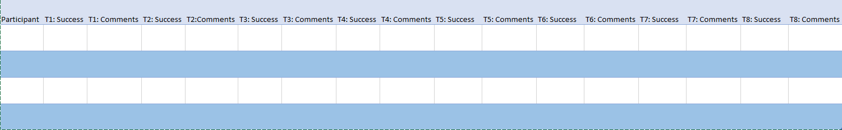



# End of Participant Study Survey

Thank you for participating in this usability study of Better Banner. To further help with this study, we would ask that you participate in this survey regarding your experience with Better Banner. This survey should only take about 5 minutes and we appreciate all of your responses.

1. **Rate from 0 – 5 (five being the best): Better Banner was an attractive website.**

< 0 1 2 3 4 5 >

1. **Rate from 0 – 5 (five being the best): Navigation was easy and intuitive and made finding the pages I needed to get to very easy.**

< 0 1 2 3 4 5 >

1. **Do you have any opinions regarding the navigation of Better Banner? Be as open as possible, we can take the heat!**
2. **Please rate your overall experience with Better Banner compared to the current myBanner. (0 = Better Banner was much worse than myBanner, 5 = Better Banner was way better than myBanner).**

< 0 1 2 3 4 5 >

1. **Please note any comments you have regarding the Better Banner system compared to myBanner. Was the overall experience better or worse for you?**



# myBanner Expert Analysis Questionnaire

The following questionnaire will be used to assess your level of expertise of myBanner. If you would like to be selected for a expert myBanner user in the Better Banner usability study, you must fill out this questionnaire. Successful candidates will be contacted of their access to the study. If you are applying to be a standard user, you do not need to take this questionnaire.

1. **How many semesters have you used myBanner?**
2. **Please explain the process of signing up for new classes in myBanner. Please be as detailed as possible and explain the methods you chose and why.**
3. **How would you use myBanner to get a parking pass? Please explain in detail the process and steps you would take.**
4. **How often do you use myBanner in a month?**
   1. 0
   2. 1 – 2 times / month
   3. 3 – 4 times / month
   4. 5 – 6 times / month
   5. > 6 times / month
5. **Why do you believe you should be considered for the expert user analysis in the Better Banner usability study?**